Pauwels Travel Bureau Ltd.
55 Dufferin Ave Brantford, ON N3T 2J1
Tel: (519) 753- 2695/1-800-380-3974, Fax: (519) 753-6376
E-mail: tours@pauwelstravel.com www.pauwelstravel.com

ANTIQUE FAIRS AND LONDON MARKETS
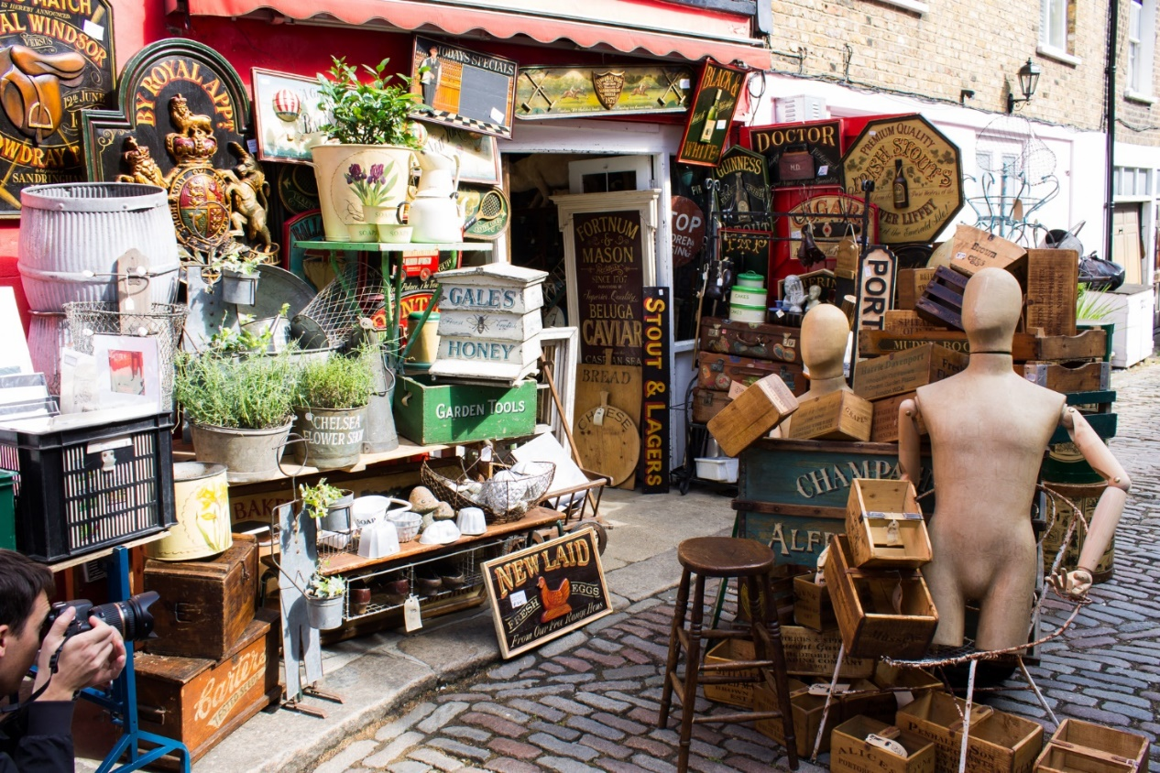
Sunday, September 5 – Tuesday, September 14, 2021
Join Steve and Sandra on an English treasure hunt. Dig through antique shops, chat with local artisans, line up at the market with locals, and haggle your way through a stall or two and search for treasures at the largest antique fair in Southern England. We hope you've got lots of room in your suitcase to bring back all of the unique bargains you find, if not we can help you ship it!
Tour Cost: $2975.00 Land Only, per person sharing twin/double accommodation
Single Supplement: $1350.00
*Please note at time of printing the lowest available group airfare was just over $1000 per person while individual airfares remained under $800. Once the departure is guaranteed we will reassess the best possible airfares and advise the various rates. Participants will be offered the best possible price without service charge at that time.

Proposed Itinerary:
Day 1 - Sunday, September 5: FLIGHT
Evening departure on British Airways direct service (or similar) to London, Heathrow. Full inflight services provided. (**See note above regarding airfares).

Day 2 – Monday, September 6: BRIGHTON
Arrive at London Heathrow where we will meet and take you to Brighton. We start our visit in the city beside the seaside with a glass of award winning Nvetimer Cuvee in the British Airways i360, a 450-foot, futuristic glass pod with fantastic, 360 degree views of the city. We continue our orientation with a guided tour through the famous Lanes which will conclude with a special tour of the Royal Pavilion, the lavish, seaside palace of King George IV and one of the most dazzlingly beautiful buildings in England. Following the tour we make our way to the hotel and our home for the next three nights, Jurys Inn Waterfront.

Day 3 – Tuesday, September 7: BRIGHTON
After an early breakfast, you’ll be on your way to the Ardingly International Antiques and Collectors Fair, the largest in the south east of England where you’ll find up to 1,700 stalls housing thousands of goods – from fine antique furniture to delicate ceramics. If quality European decorative items are on your shopping list, this is the place to find them. Return to Brighton in time to freshen up before meeting in the lobby and heading off for a welcome dinner at one of Brighton’s many fine restaurants.

Day 4 – Wednesday, September 8: BRIGHTON
Because of its size, you might want to return for a second visit to the Ardingly Antique Fair. Alternatively, you may prefer a later start and spend the day discovering Brighton’s many antique shops and flea markets in the labyrinth of twittens (very narrow alleyways) in the Lanes just behind the seafront or the expansive North Laine which is the bohemian heart of the city. Make time to visit Kemp Town, Brighton’s hidden gem. No group dinner this evening. The city was named as the top destination in the country for restaurants and bars by the readers of Conde Nast Traveler magazine, so you will have plenty of places to choose from. Being a city by the sea there are great places for seafood.
Day 5 – Thursday, September 9: LONDON
Departure after breakfast for London. Enroute we will stop to visit the double moated Hever Castle, once the childhood home of Anne Boleyn, second wife of Henry VIII and Mother of Elizabeth I, and of William Waldorf Astor, who used his fortune to restore and extend the Castle in the early 20th century. Once checked into your London hotel, The Rembrandt. This evening is free, but your tour leaders will be sending a list of activities before your departure that you may wish to consider doing during your stay.

Day 6 – Friday, September 10: LONDON
London is at your beck and call for the next 3 days and today is our opportunity to spend a few hours at the historic Bermondsey antique market where traders sell everything from cutlery to furniture, china to jewellery, antiques and the unexpected. It starts at 6:00 am and runs through to 2:00 pm, rain or shine. While you’re in this corner of London, you might like to add a visit to the Fashion and Textile Museum, a cutting-edge centre for contemporary fashion and textiles in London, founded by iconic British designer Zandra Rhodes.

Day 7 – Saturday, September 11: LONDON
This morning’s highlight is undoubtedly Portobello Road, the world’s largest antiques market with over 1,000 dealers selling every kind of antique and collectible. It opens at 9 am so we will get there early to avoid the worst of the midday crowds. At lunchtime, you might want to head to Harrods and then explore the boutiques on Sloane Street and the Kings Road. Alternatively, this would be a good day for your own independent sightseeing. Steve will be sending a list of the Premiership football matches for anyone interested in attending a live match.

Day 8 – Sunday, September 12: LONDON
After breakfast, we will take you to the colourful Columbia Flower Market where you’ll thoroughly enjoy a visit to Angela Flowers Perfumery, a cult shop that attracts visitors from all over the world and where they are passionate about artisan perfumery. Then join thousands of Londoners in the bustling Spitalfields and Petticoat Lane Markets. While in the area we’ll include a visit to the fascinating Dennis Severs House, a time capsule that gives an intimate portrait of the lives of a family of Huguenot silk-weavers from 1724 to the dawn of the 20th Century. Absolutely NO talking is allowed.

Day 9 – Monday, September 13: LONDON
Our last full day in London so we have left it free for individual activities, perhaps a cooking school, brewery tour, an excursion to High Clare Castle (Downton Abbey), or a trip out to Silverstone raceway. This evening we will have a farewell dinner at one of London’s fine restaurants.

Day 10 – Tuesday, September 14: FLIGHT
Breakfast at the hotel before transferring to London Heathrow for the return flight home to Toronto. (Please see note below regarding airfares).

WELCOME HOME!

Tour Cost: $2975.00 Land Only, per person sharing twin/double accommodation
Single Supplement: $1350.00
*Please note at time of printing the lowest available group airfare was just over $1000 per person while individual airfares remained under $800. Once the departure is guaranteed we will reassess the best possible airfares and advise prices. Participants will be offered the best available rate without service charge at that time.

Price includes:
- 8 nights’ accommodation based on two people sharing a room
- Daily breakfast
- Welcome and farewell dinner
- All sightseeing as per the above itinerary
- Private coach for airport transfers , sightseeing and touring as stated in itinerary
- A pre-loaded visitor Oyster pass good for 4 days in London
- Entrances and admissions as per the program
- Porterage of one suitcase
- Services of a tour leader

Not Included:
- Meals not specified
- Items of a personal nature
- Travel insurance, please contact the office for rates

TERMS & CONDITIONS

RESERVATIONS AND DEPOSITS:
Reservations should be made as early as possible to ensure the departure of your choice. A deposit of $750.00 required at the time of registration. Your reservation is confirmed upon receipt of your deposit and registration form. No reservations will be accepted without a signed registration form.

REFUND OF UNUSED ARRANGEMENTS:
Because the rates of Pauwels Travel Bureau Ltd. are based on group participation, no refund can be made for any tour accommodation or tour service or tour feature not taken. If cancellation occurs while the tour is in progress, no refund can be made for the tour portion not taken. We strongly suggest that to allow for any unexpected contingencies, you purchase the all-inclusive insurance.

CANCELLATION POLICY:
Refund of deposit is made if cancellation is received in writing by Pauwels Travel Bureau Ltd. more than 90 days prior of the departure date of the tour. For cancellation received in writing 90 days prior or less the following cancellation charges apply:
90 days to 61 days before departure: 25% of tour cost
60 to 31 days before departure: 50% of tour cost
Within 30 days prior to departure: 100% of tour cost

RESPONSIBILITY:
The acceptance of the initial service to be provided under the tour shall be considered an acceptance by the tour member of those conditions. We also reserve the right to decline, to accept or retain any person as a member of the tour. We reserve the right without notice, to withdraw any part or all of the tour. Factors such as airline schedule changes, hotel overbookings, inclement weather, travel warnings by the Canadian Government etc. may necessitate changes in the itinerary. There may also be other circumstances in which changes become necessary or advisable.
By commencing the tour, I agree to the release and agreement as included below.

RELEASE & AGREEMENT:

By placing my deposit and commencing the tour I understand and agree to the following:

- That all tours are delivered in conjunction with other service providers, including but not limited to travel agent and booking services, airlines, hotel and accommodation providers, transportation providers including but not limited to coach, train and ferry services, restaurant providers, and local guides. We shall not be held responsible for the failure by any person or company to render any transportation, lodging or other travel service to be provided on the tour. All hotels, transportation and other travel services are provided subject to all the terms and conditions under which they are offered to the public generally.

- I know that tour programs include walking, and may including hiking and fitness programs that have potential hazardous activities associated with them. I should not participate prior to approval by my physician. I assume any and all other risks associated with these events included but not limited to falls, contact with other participants, the effects of the weather including high heat and/or humidity.

- To release, indemnify and hold harmless Pauwels Travel Bureau and their affiliates (which term shall include parents, subsidiaries, officers, directors, shareholders, agents and employees of Pauwels Travel Bureau as well as Pauwels Travel themselves) (the “Released Parties”) from, and agree not to sue the Released Parties for, any claims that I may have arising from, or in connection with, any personal injury, bodily injury, mental anguish, emotional distress, physical, property or other damage that I may suffer from any cause whatsoever related in any way to my participation in this tour. Without limiting the generality of the foregoing, I release, indemnify and hold harmless the Released Parties from, and agree not to sue them for any personal injury, bodily injury, mental anguish, emotional distress, physical, property or other damage that I may suffer from the Released Parties’ negligence other than from intentional or reckless acts by such parties. I further agree to release, indemnify and hold harmless the Released Parties from any and all acts of God, war (whether declared or undeclared), terrorist activities, incidents of politically motivated violence, illness or quarantine, strikes or government restrictions or the acts or omissions of any other agents over which the Released Parties have no direct or indirect control, including, without limitation, airlines, railways, bus companies, hotels, shipping companies, guides and sub-contracted agents or tour operators. This release also includes activities not offered that may be considered risky. I further release any Tour Directors, bus drivers or other individuals involved in my tour.

- That the air carrier’s liability for loss of or damage to baggage or property, or for death or injury to person, is limited by their tariffs, or the Warsaw Convention, or both.

- That Pauwels Travel Bureau shall have no liability or responsibility for me when I am absent from activities, such as visits to friends or relatives or during stay-ahead/stay-behind option periods if the stay-ahead/stay-behind period does not include the services of a Tour Director.

- To abide by directions of my Tour Director or other leadership personnel during my tour. Failure to do so may result in my termination from tour immediately. I understand that to disobey such rules or directions are to waive the right to any refund, and that I may be sent home at my own expense. The participant and family undertake full financial responsibility for any damage caused by the participant and agree to pay his/her return home on the first available flight, should his/her behavior be deemed detrimental to the welfare of the group.

- To abide by all local laws when in Canada and abroad, including those concerning drugs and alcohol. (Minors must have parents’ permission to use alcohol even if the local law would otherwise permit them to.) I understand that if I abuse or disobey such laws, even unintentionally, I waive my right to a refund, and Pauwels Travel may send me home at my own expense. I also understand that should local authorities be involved, I will be subject to the laws of the country I am visiting.

- That if I become ill or incapacitated, Pauwels Travel and its employees, or a designated chaperone may take any action they deem necessary for my safety and well-being, including securing medical treatment (at my own expense) and transporting me home. Pauwels Travel retains the right, in its sole discretion, to contact the traveller’s parent(s) and/or guardian or emergency contact with regard to health issues or any matters whatsoever that relates to the traveller’s tour. These rights transcend any and all privacy regulations that may apply. In the event of a medical emergency, Pauwels Travel will attempt to cause appropriate treatment to be administered, and the traveller authorizes Pauwels Travel to do so. Pauwels Travel, however, makes no warranty that it will be able to cause effective (or any) emergency treatment to be administered.

- That Pauwels Travel may use any film likenesses taken of me and any of my comments while on a tour for future publication and also use my contact information for future Pauwels Travel communications.

A WORD ABOUT GROUP AIRFARES:

Please note that when booking one of our air inclusive tours, Pauwels Travel has negotiated reduced rates with the airline that we are able to confirm and lock in up to 359 days before travel. While it is wonderful to share the savings and flexibility this provides with you, our valued guests, the privilege does come with some restrictions. In some cases it may not be possible to collect frequent flyer miles, you may not be able to check in online 24 hours before travel, or you may need to try checking in with your ticket number rather than your booking reference and, in almost ALL cases we are not able to offer advanced seat selection.

It is the airline that makes the reservation and has control over the booking so it is their policy, not ours, that prevents us from assigning specific seats. If a request is made, it is passed on to the airline by our staff when they submit the names to the airline, i.e., 30-60 days prior to departure. Calling us several days before you leave will not change this fact nor will getting upset with our staff.

If a certain type of seat is indispensable to you, we suggest that you book our tour on a “land only” basis and make individual flight arrangements, in which case you may be able to get the seat of your choice; Pauwels Travel would be happy to assist you with that reservation at absolutely no additional charge. We will offer you the best fare available, but please note that this can only be done once a tour is a guaranteed departure because your individual airfare’s conditions are likely to involve cancellation penalties.

We thank you in advance for your kind understanding of the above!
REGISTRATION FORM

Please book _____ seat(s) on “Antique Fairs and London Markets” tour of September 5 – 14, 2021.
Enclosed is my/our deposit of ___________ ($750 per person, plus insurance premium if taken.)
Please indicate with an X if you intend to travel on Group flights_______ or Land only_______.
Deposit and insurance premium, if taken, are due with registration. You will be invoiced for an interim payment of $1,000.00 and the balance due 45 days prior to departure.
WE REQUIRE A COPY OF YOUR PASSPORT (INFORMATION PAGES ONLY) VALID 3 MONTHS AFTER TOUR TO BE SENT IN WITH YOUR REGISTRATION.
PASSPORT NAME(S): Please indicate the appropriate title (Mr., Mrs., Miss, Dr., Ms.)
Surname______________________First__________________Middle(s)______________________
Surname______________________First__________________Middle(s)______________________
If applicable, give your commonly used first name as you would like it to appear on your name tag: (e.g. “Liz” for “Mary Elizabeth”) ____________________________________________________________________________
Address_________________________________________________________________________
Postal Code: ____________Phone: ________________Email_______________________________
If traveling alone, is a SINGLE ROOM REQUIRED? YES_____ NO_____
If sharing, what is your bed preference: twin_______________ double_______________?
SPECIAL REQUIREMENTS: We find the earlier a request is made, the more success we have in filling it, so please list any dietary requests, allergies, any special physical needs or frequent flyer numbers etc here. We cannot ensure requests made 30 days or less prior to departure will be possible.
_________________________________________________________________________________
Insurance, Please call the office for premiums then record it on application and add premium to deposit.
I /we would like to purchase (please check and record your rate):
Name: _______________________________________ Date of Birth:_____________________
Name: _______________________________________ Date of Birth:_____________________
All-inclusive Package ______________________ Non-medical Package ______________________
Other ___________________ OR Decline Insurance ___________________________________
PAYMENT: Cheque payable to Pauwels Travel Visa Mastercard American Express
Amount Paid: _________________________Card Number: _______________________________
Expiry: ___________ Security Code: __________ Signature: ______________________________
“I/we agree to the terms and conditions attached to the program, have indicated our insurance choice, indicated any special requests and included payment”.
Date_______________Signature(s)________________________________________________
Please forward this completed and signed form, copy of passport and payment to:
PAUWELS TRAVEL BUREAU LTD.
55 Dufferin Ave, Brantford, Ontario N3T 4P6
Tel: 519-753-2695/1-800-380-3974/ Fax: 519-753-6376 Email: tours@pauwelstravel.com

